# **Домашнее задание 5. Дискретная случайная величина**

Камаров Лазизбек БИВ201

|  |  |  |  |
| --- | --- | --- | --- |
| X | 3 | 4 | 5 |
| Исходы | + + + | + + - +  + - + +  - + + + | - -  - + -  + - -  - + + -  + - + -  + + - - |

|  |  |  |  |
| --- | --- | --- | --- |
| X | 3 | 4 | 5 |
| P |  |  |  |

|  |  |  |  |
| --- | --- | --- | --- |
| X | 3 | 4 | 5 |
| P | 0.008 | 0.0192 | 0.9728 |

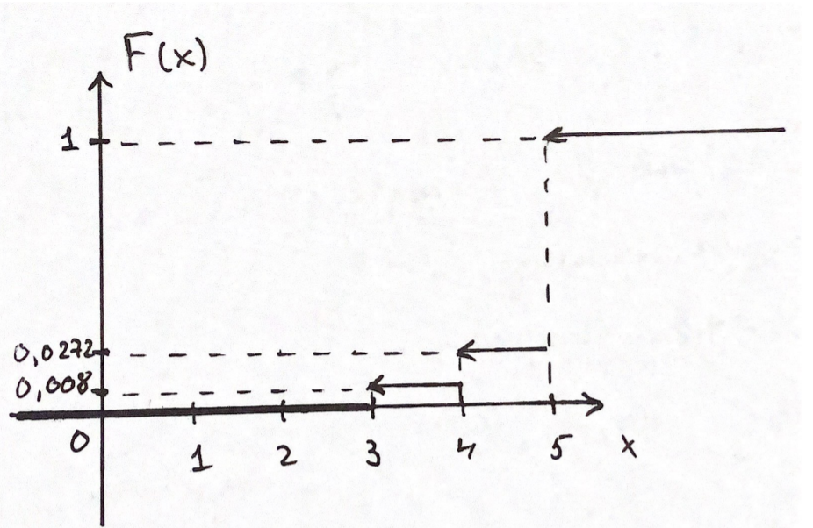

|  |  |  |  |  |  |
| --- | --- | --- | --- | --- | --- |
| Х | 1 | 2 | 3 | 4 | 5 |
| Исходы | + | - + | - - + | - - - + | - - - - + |

|  |  |  |  |  |  |
| --- | --- | --- | --- | --- | --- |
| Х | 1 | 2 | 3 | 4 | 5 |
| Р |  |  |  |  |  |

|  |  |  |  |  |  |
| --- | --- | --- | --- | --- | --- |
| Х | 1 | 2 | 3 | 4 | 5 |
| Р |  |  |  |  |  |

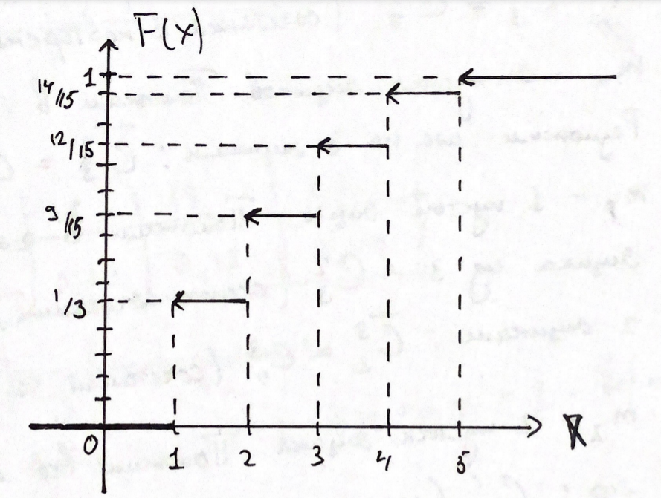

|  |  |  |  |  |  |
| --- | --- | --- | --- | --- | --- |
| Х | 1 | 2 |  | k |  |
| Р |  |  |  |  |  |

|  |  |  |  |  |  |
| --- | --- | --- | --- | --- | --- |
| Х | 1 | 2 |  | k |  |
| Р |  |  |  |  |  |

|  |  |  |  |
| --- | --- | --- | --- |
| X | 0 | 1 | 2 |
| P |  |  |  |

|  |  |  |  |
| --- | --- | --- | --- |
| X | 0 | 1 | 2 |
| P |  |  |  |

|  |  |  |  |
| --- | --- | --- | --- |
| X | 0 | 1 | 2 |
| P |  |  |  |

|  |  |  |  |
| --- | --- | --- | --- |
| X | 0 | 1 | 2 |
| P |  |  |  |

|  |  |  |  |  |  |
| --- | --- | --- | --- | --- | --- |
| Х | 16 | 17 | 18 | 19 | 20 |
| Исходы | 8,8 | 8,9  9,8 | 8,10  9,9  10,8 | 9,10  10,9 | 10,10 |

|  |  |  |  |  |  |
| --- | --- | --- | --- | --- | --- |
| Х | 16 | 17 | 18 | 19 | 20 |
| P |  |  |  |  |  |

|  |  |  |  |  |  |
| --- | --- | --- | --- | --- | --- |
| Х | 16 | 17 | 18 | 19 | 20 |
| P | 0.25 | 0.3 | 0.29 | 0.12 | 0.04 |